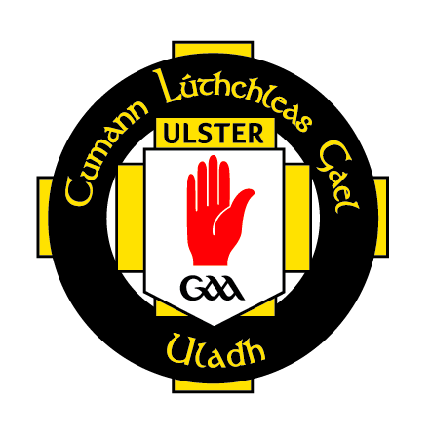
Social and Recreational GAA

What’s it all about?
Recreational/Social GAA is an opportunity for
all members of our association to participate
in a fun, non-competitive environment.

Benefits
• Fun, enjoyment, exercise, health and fitness.
• Social outlet, friendships.
• Opportunity for past players/members to
get reacquainted with the club.
• Recreational/Social games can help create
a buzz around the club.

Some Questions
• Who can play? Recreational games should
be available to anyone.
• Where is it played? Recreational games can
be played indoor or outdoor on grass or
astro-turf.
• When can it be played? Recreational games
can be played all year round at any time of
the day depending on facilities available.
• Is a referee required? Ideally but not
necessarily.
• Any special equipment required? None.

Get back
in the
game!

How is it organised?
• Key person within club is required to promote the concept.
• Organise games within the club or against neighbouring clubs
• Clusters of clubs or divisional boards can drive the initiative to make
it more official.
• Organise games in conjunction with local carnivals, GAA festivals or
family fun days.
• Organise social games within your workplace. This could eventually
lead to formation of an inter-firms team.

Team options
• Over 35 or 40 (male or female only).
• Mixed teams (male and female of any age).
• Anyone who does not currently represent their club on the field of play.
• Everyone and anyone!

Rules
• Incidental contact only (No tackling).
• Gaelic Football - 2 touches max (one solo and/or one bounce).
• Hurling - Soloing is not permitted.
• Whoever is fouled takes the free.
• Duration of game agreed by teams but recommended breaks every
10 minutes.

UPCOMING EVENT
Thu 29 Oct | Regional Development | Recreational GAA | Antrim | 7 PM

Recreational GAA is a great opportunity for older club members to have a bit of fun and keep themselves fit and healthy.

If your club is interested in entering a team(s) or even hosting the event, please contact me so we can get things arranged and details sent out to clubs.

Yours in Sport,

Shane McCann

Regional Development Officer
Ulster Council (Antrim & Down)

Email: shane.mccann.ulster@gaa.ie
Phone: 07920528793

